SCHOOL OF COMPUTER SCIENCE AND ARTIFICIAL INTELLIGENCE |  |  |  |  | DEPARTMENT OF COMPUTER SCIENCE ENGINEERING
Program Name: B. Tech |  |  |  | Assignment Type: Lab |  |  | Academic Year:2025-2026
Course Coordinator Name |  |  |  | Venkataramana Veeramsetty
Instructor(s) Name |  |  |  | Dr. V. Venkataramana (Co-ordinator)  Dr. T. Sampath Kumar  Dr. Pramoda Patro  Dr. Brij Kishor Tiwari  Dr.J.Ravichander  Dr. Mohammand Ali Shaik  Dr. Anirodh Kumar  Mr. S.Naresh Kumar  Dr. RAJESH VELPULA  Mr. Kundhan Kumar  Ms. Ch.Rajitha  Mr. M Prakash  Mr. B.Raju  Intern 1 (Dharma teja)  Intern 2 (Sai Prasad)  Intern 3 (Sowmya)  NS_2 ( Mounika)
Course Code |  |  | 24CS002PC215 | Course Title |  | AI Assisted Coding
Year/Sem |  |  | II/I | Regulation |  | R24
Date and Day  of Assignment |  |  | Week6 - Monday | Time(s)
Duration |  |  | 2 Hours | Applicable to  Batches
AssignmentNumber:12.1(Present assignment number)/24(Total number of assignments)
 | Q.No. | Question |  |  |  |  |  | Expected Time  to complete
 | 1 | Lab 12: Algorithms with AI Assistance – Sorting, Searching, and Optimizing Algorithms  Lab Objectives:  - Apply AI-assisted programming to implement and optimize sorting and searching algorithms.  - Compare different algorithms in terms of efficiency and use cases.  - Understand how AI tools can suggest optimized code and complexity improvements.  Task Description #1 (Sorting – Merge Sort Implementation)  - Task: Use AI to generate a Python program that implements the Merge Sort algorithm.  - Instructions:  - Prompt AI to create a function merge_sort(arr) that sorts a list in ascending order.  - Ask AI to include time complexity and space complexity in the function docstring.  - Verify the generated code with test cases.  - Expected Output:  - A functional Python script implementing Merge Sort with proper documentation.  PROMPT:  Create a Python function called merge_sort(arr) that implements the Merge Sort algorithm to sort a list in ascending order.  The function should be well-documented, and its docstring must include the time complexity and space complexity of the algorithm.  After defining the function, provide a few test cases to verify that it works correctly. The test cases should print the sorted output for given example lists.  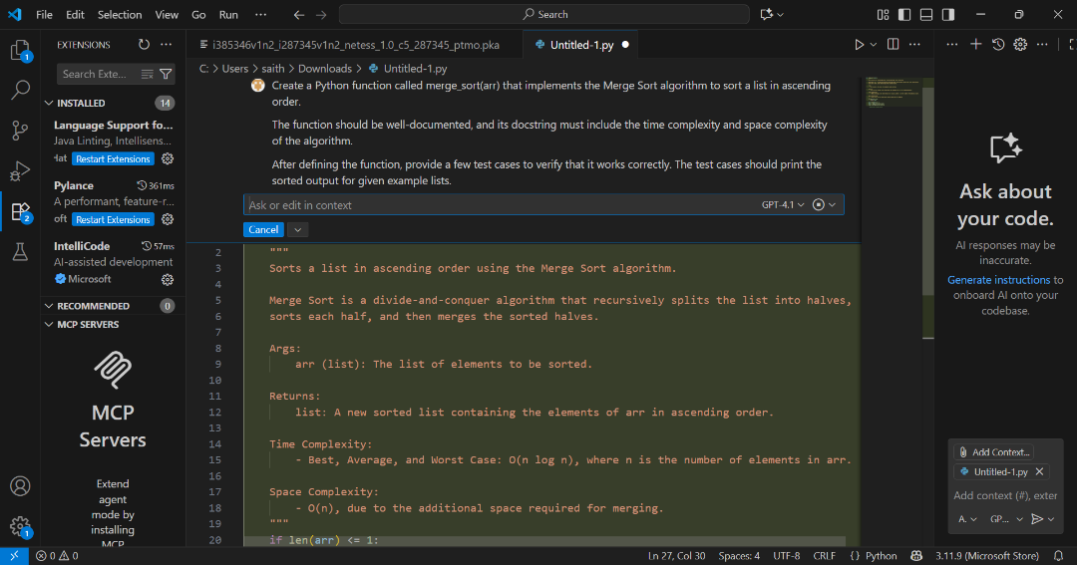  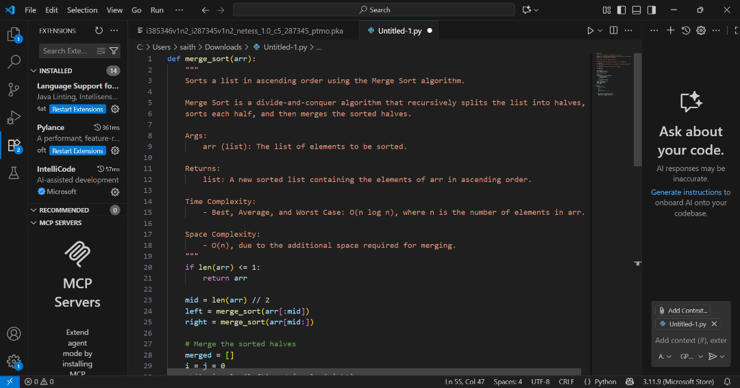  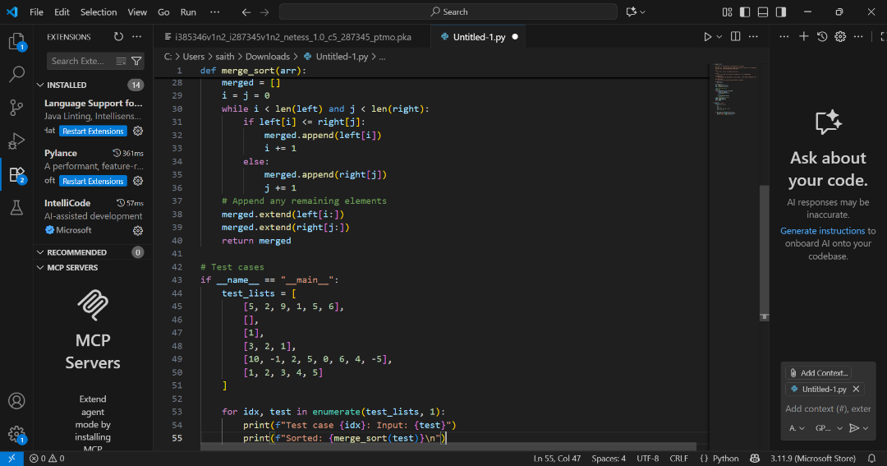  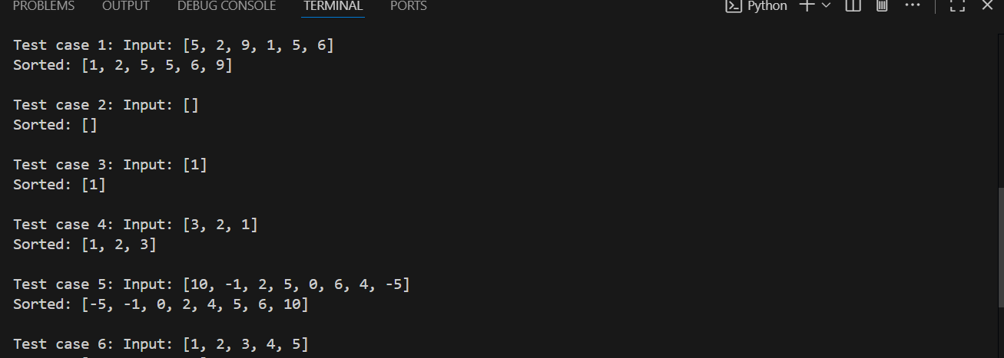  Task Description #2 (Searching – Binary Search with AI Optimization)  - Task: Use AI to create a binary search function that finds a target element in a sorted list.  - Instructions:  - Prompt AI to create a function binary_search(arr, target) returning the index of the target or -1 if not found.  - Include docstrings explaining best, average, and worst-case complexities.  - Test with various inputs.  - Expected Output:  - Python code implementing binary search with AI-generated comments and docstrings.  PROMPT:  Write a Python function named binary_search(arr, target) that performs a binary search on a sorted list to find the index of a given target element.  The function should return the index of the target if found, or -1 if the target is not in the list.  Include a detailed docstring that explains what the function does and provides the best-case, average-case, and worst-case time complexities.  Add inline comments explaining key steps in the algorithm.  Finally, include several test cases with print statements to demonstrate that the function works correctly for various inputs  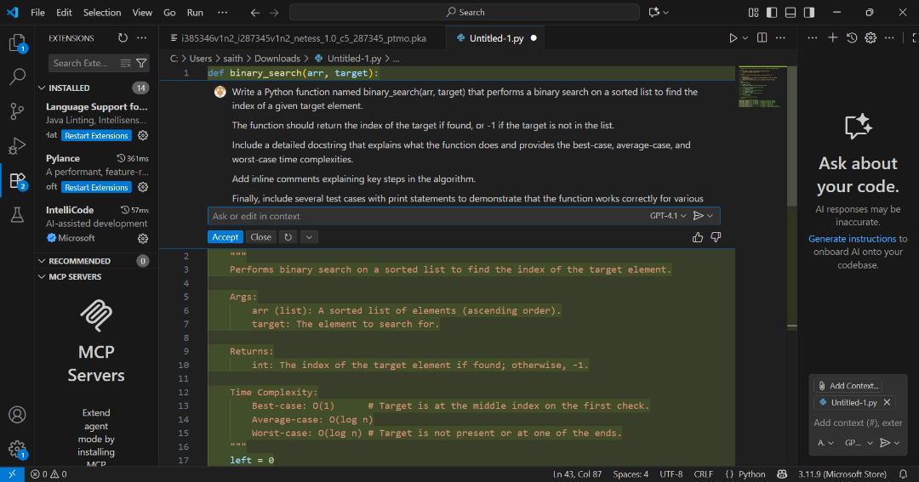  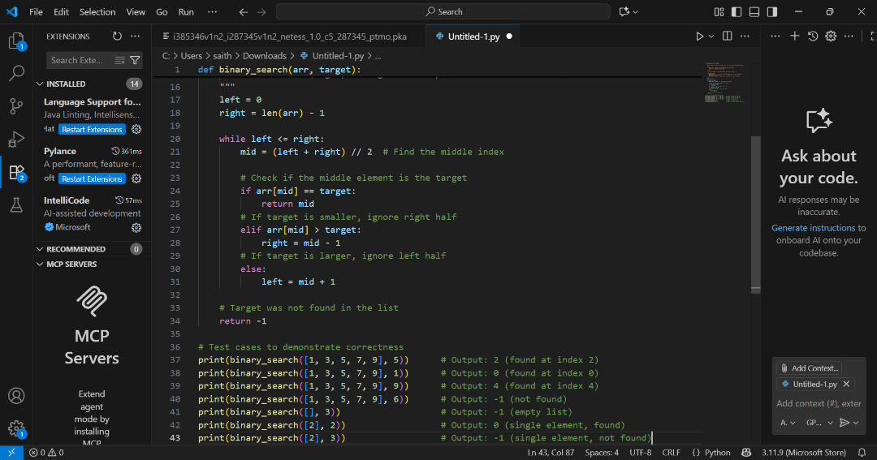  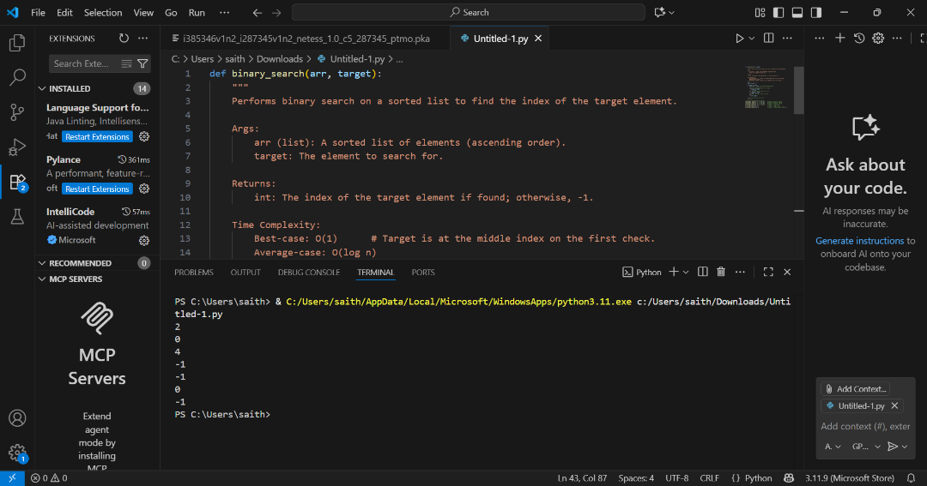  Task Description #3 (Real-Time Application – Inventory Management System)  - Scenario: A retail store’s inventory system contains thousands of products, each with attributes like product ID, name, price, and stock quantity. Store staff need to:  - Quickly search for a product by ID or name.  - Sort products by price or quantity for stock analysis.  - Task:  - Use AI to suggest the most efficient search and sort algorithms for this use case.  - Implement the recommended algorithms in Python.  - Justify the choice based on dataset size, update frequency, and performance requirements.  - Expected Output:  - A table mapping operation → recommended algorithm → justification.  - Working Python functions for searching and sorting the inventory.  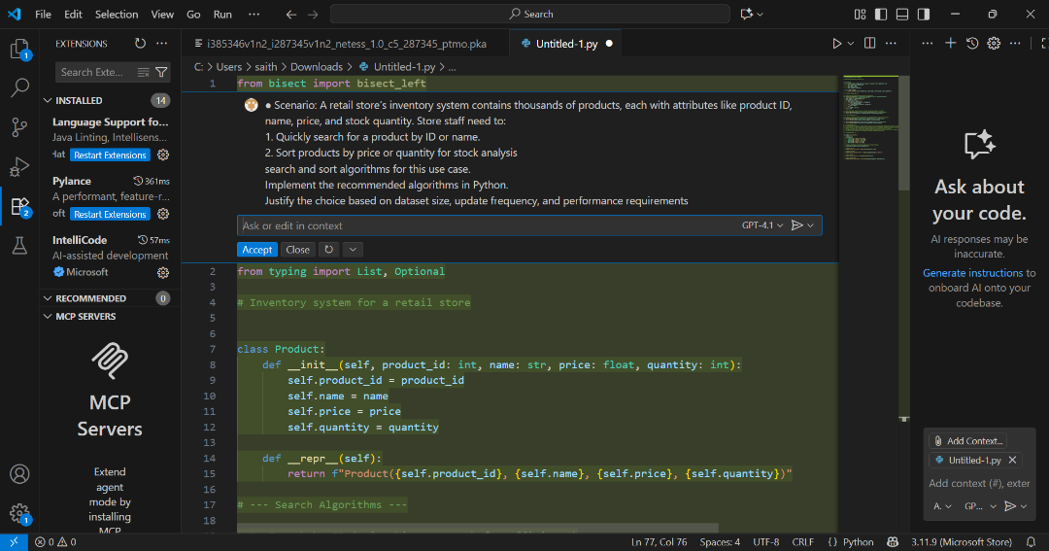  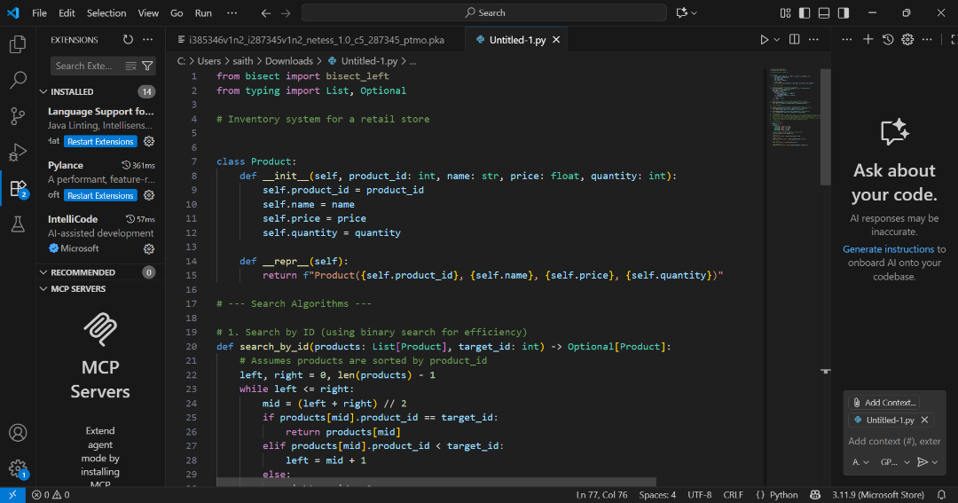  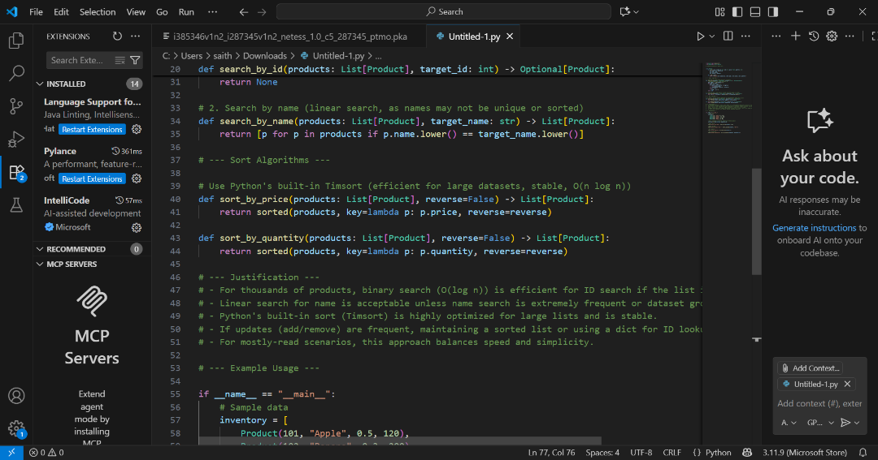    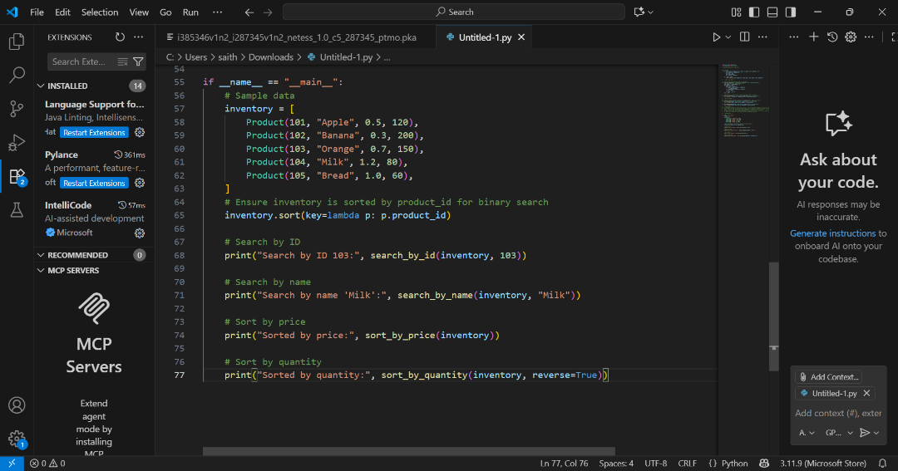  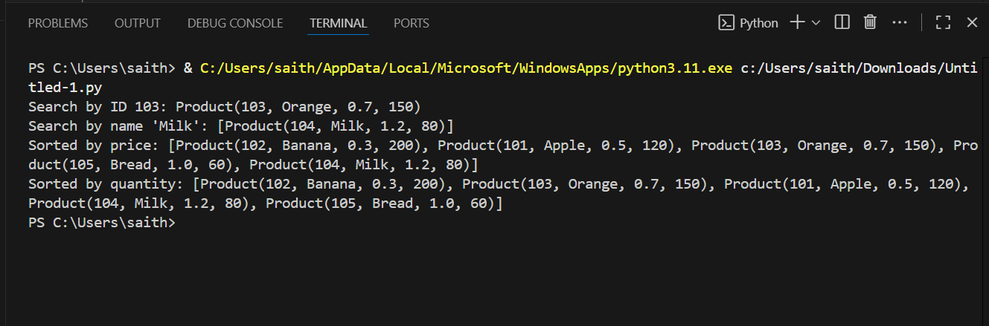  ✅ Deliverables (For All Tasks)  - AI-generated prompts for code and test case generation.  - At least 3 assert test cases for each task.  - AI-generated initial code and execution screenshots.  - Analysis of whether code passes all tests.  - Improved final version with inline comments and explanation.  - Compiled report (Word/PDF) with prompts, test cases, assertions, code, and output. |  |  |  |  |  | Week6 - Monday

